20150710

Multipath Helper
https://access.redhat.com/labs/multipathhelper/#/

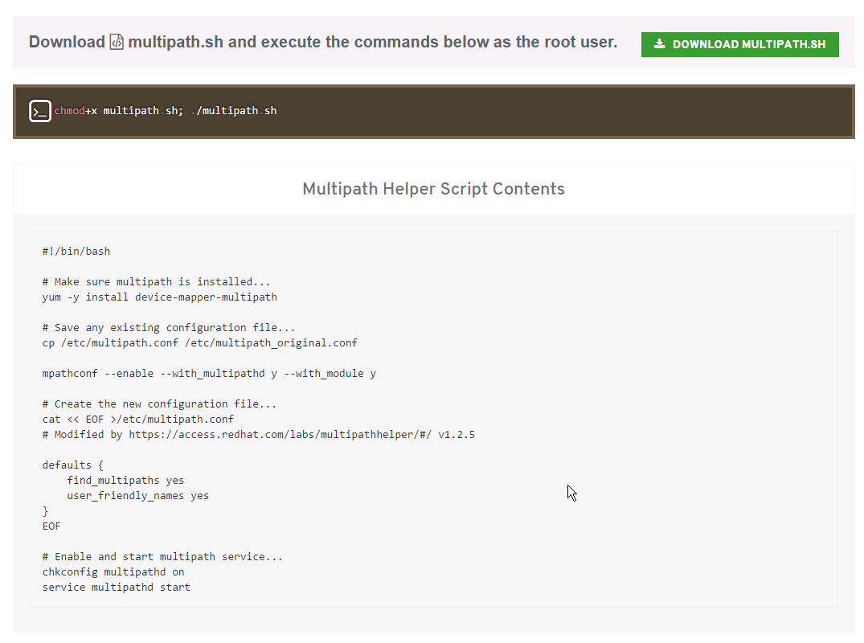

#!/bin/bash

# Make sure multipath is installed...
yum -y install device-mapper-multipath

# Save any existing configuration file...
cp /etc/multipath.conf /etc/multipath_original.conf

mpathconf --enable --with_multipathd y --with_module y

# Create the new configuration file...
cat << EOF >/etc/multipath.conf
# Modified by https://access.redhat.com/labs/multipathhelper/#/ v1.2.5

defaults {
find_multipaths yes
user_friendly_names yes
}
EOF

# Enable and start multipath service...
chkconfig multipathd on
service multipathd start

